Ahtahkakoop walks a mile in heels to help abused women

Written by Chelsea Laskowski
Wednesday, 24 August 2016 11:24
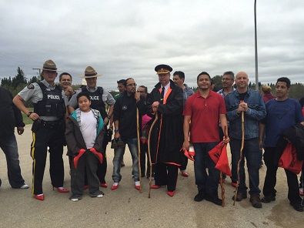
The Ahtahkakoop Walk a Mile event. Photo courtesy @Cooper_Chief, Twitter
The men of Ahtahkakoop Cree Nation are resting their feet this week, after walking a mile in bright red heels on Tuesday.
The Walk a Mile in her Shoes event is now in its second year on the Prince Albert-area reserve, organized by the Cree Nations Treatment Centre which serves clients from Ahtahkakoop, Big River, Pelican Lake and Witchekan Lake.
Suffering the cold weather and rain was well worth it when they could present a check for more than $3,700 to the Prince Albert women's shelter.
Freda Ahenakew is the treatment centre's executive director and was one of the organizers for the Walk a Mile event.
"We do use those shelters for women who are abused. There's a lot of it that goes in every community. We have clients coming in here too and if they choose to go to the shelter we make arrangements for them to go. Doesn't matter from what district they are," Ahenakew said.
They also want to inform people in their community about how often First Nations women are murdered or go missing.
For Ahenakew, that issue affects her work life and the lives of so many community members.
"The grief and loss, we get a lot of people come through here because they've lost a loved one. It's hard for people to cope that's why they turn to drugs and alcohol," she said.
And even though the cause is serious, the fundraising was full of family-friendly entertainment like bouncy castles, dunk tank games and live music that kept organizers busy until 11 p.m.
The weather did affect the number of participants, with about 35 men and at least one woman donning the heels. Among them were various RCMP officers, including Mountie Karen Pelletier who was on Ahtahkakoop for more than four years before a recent transfer.
Prince Albert Police Chief Troy Cooper took things a step further by offering to go in the dunk tank. A $5 bill gave people a chance to knock him into the water, Ahenakew recalled with a hearty laugh.
"He's got the heart for it too, he loves people. You always know how good their character is by how they mingle with people, and you always feel right at home with them," she said.
Barry Sasakamoose is the Ahtahakakoop community member who gained the most sponsorship for his walk on heels. He raised $816.

Last Updated on Wednesday, 24 August 2016 11:32

